Communication technology

Rhiannon Foster

Table of Contents

# Network communications between two users

To start with I had to change the IP address of my computer, to do this I had to go into Network and Sharing Centre of which I changes the IP address as you can see in the photo below.

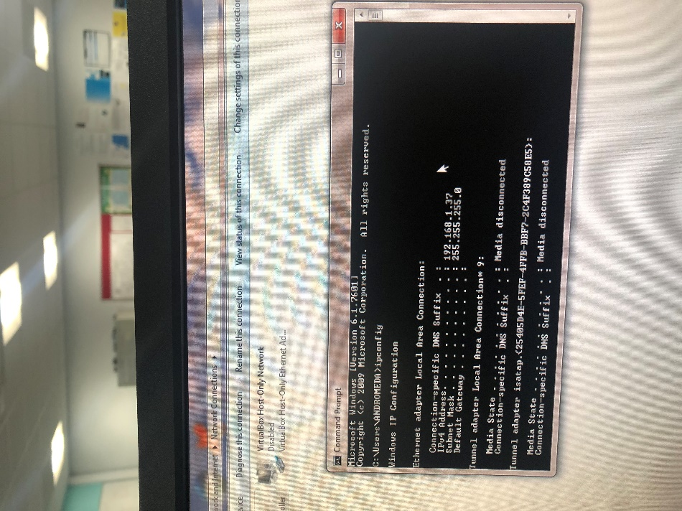

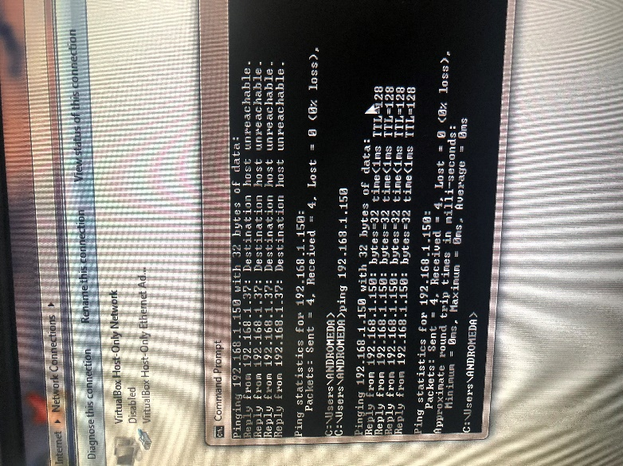in this screen print I am pinging another computer, this is where I

use the command prompt and use the command ‘ping’ and then

enter the IP address of the machine I would like to ping. The machine

will then send a reply to my machine.

I ran the ‘ping’ command and this is the data capture that I got in wireshark.

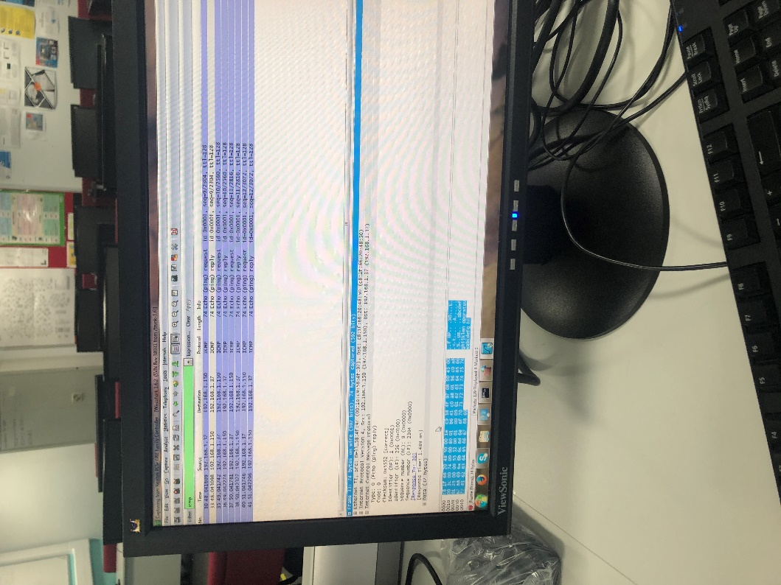

# Data Transfer

In the second part of this assignment was to transfer a medium (19gb) from one computer to another, we done this one first, the file size was exactly 19mb and we sent it from computer A to B first. We had to change the IP address and make the file.

|  |  |  |
| --- | --- | --- |
| Time (seconds) | average | Speed (gb/second(3dp)) |
| 18.66 |  |  |
| 24.78 |  |  |
| 20.37 | 20.37 | 0.932 |

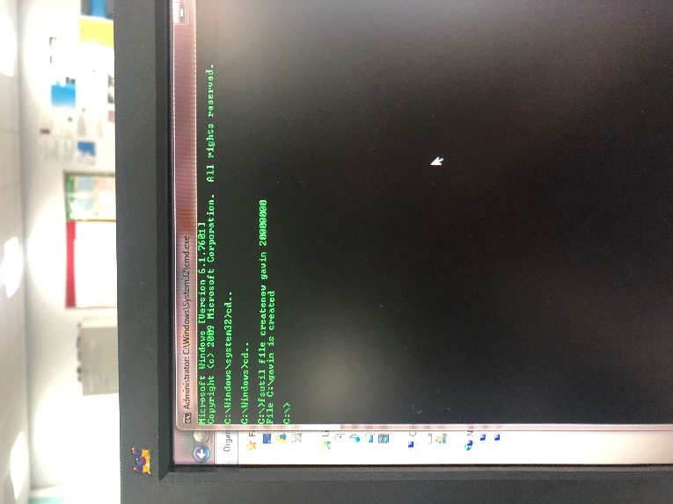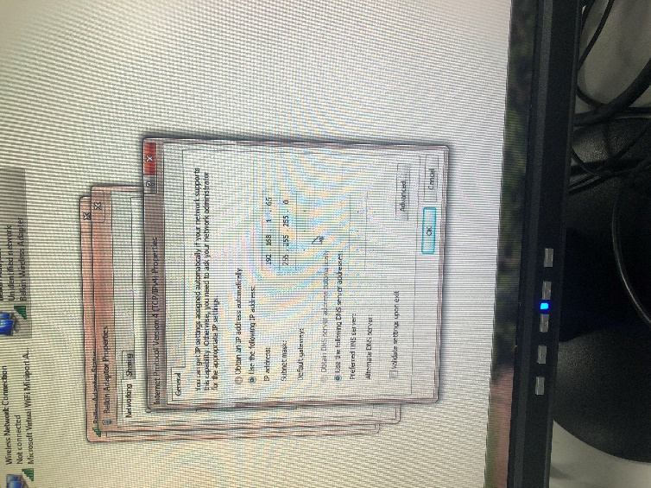

From B to A

|  |  |  |
| --- | --- | --- |
| Time (seconds) | Average | Speed (gb/second(3dp)) |
| 19.57 |  |  |
| 19.7 |  |  |
| 23.60 | 20.956 | 0.906 |

As you can see there are some differences, this could be because on A to B I started the time and on B to A Gavin started the timer so therefore the reflex time would be different, it could also be because we were doing it on different computers so therefore the time difference would vary.

We also done this with a larger file of 33.3gb on a wireless switch.

This is B to A

|  |  |  |
| --- | --- | --- |
| time(minutes) | Average | Speed(gb/minutes(3dp)) |
| 2.13.31 |  |  |
| 2.29.62 |  |  |
| 2.17.95 | 2.13.62 | 0.249 |

A to B

|  |  |  |
| --- | --- | --- |
| time(minutes) | Average | Speed(gb/minutes(3dp)) |
| 2.21.96 |  |  |
| 2.29.69 |  |  |
| 2.21.53 | 2.24.39 | 0.230 |

Again there is a clear difference but nothing to drastic, it could ne reflexes or the fact that this a wireless switch